Optimization Report

Rappid app development

LNL

Table of Contents

Software Performance testing 2

Testing types 2

Various testing software 3

WAPT 3

AppOptics 3

Optimization Report

This optimization report is being done to show that the code meets requirements, in a few areas.

* Commenting
* Readability
* PEAR Validation on PHP code

In having the above three done correctly it will mean that the code is optimized enough for readability and future modifications for any team or individuals who may come along and have to modify it.

PEAR test

adminControls.php

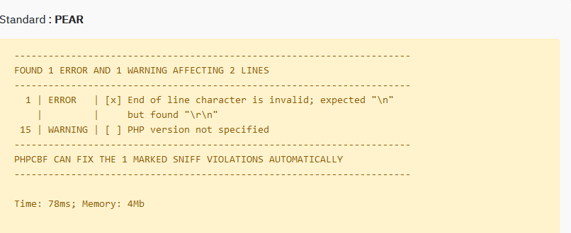

connect.php



graph_rated_scr.php



graph_scr.php



login.php



loginAdmin.php



moviesSearch_scr.php

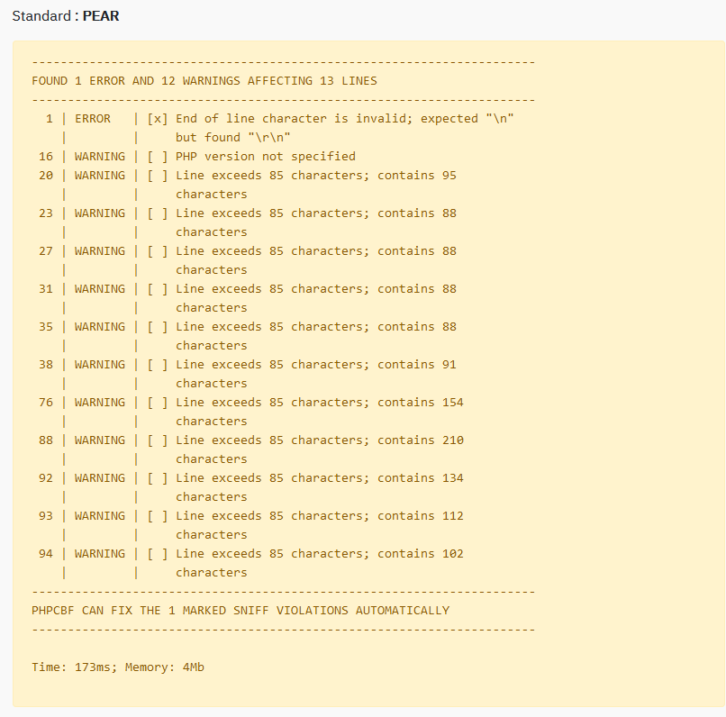

ratedGraph.php



ratingHistroy.php

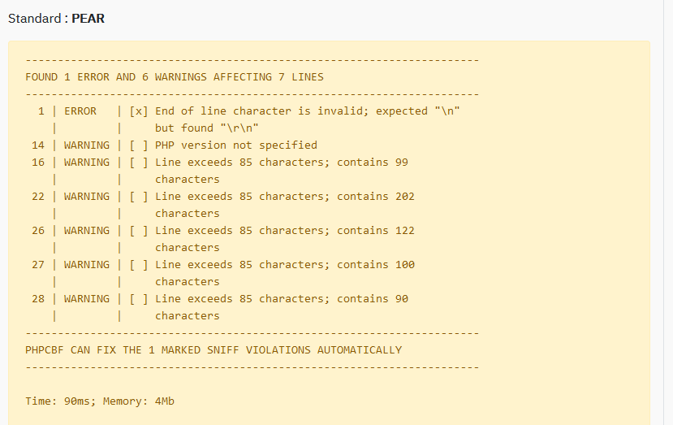

searchGraph.php



updateRatingHistory.php



Commenting

Through assessment of the code, most if not all methods or areas of complex code are commented as to allow future individuals who need to assess the code to be able to do so without complications.

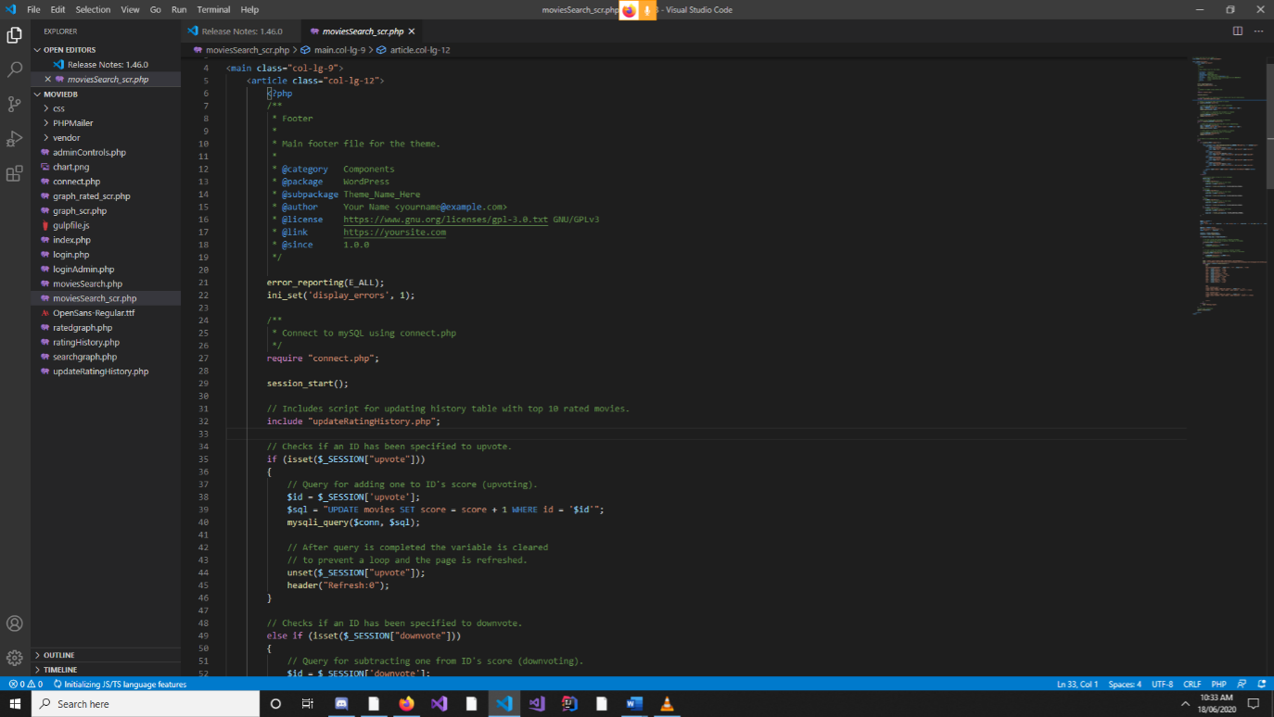

Above is an example of one of the many pages with commenting. Due to the sheer complexity and size of the program the above image will just be used as an example.